SUCCESSFUL RECREATIONAL DIVING

It is essential that a diver is well equipped at all times. Equipment
must always be properly cared for. Comfort is also an important consideration. Divers should be thoroughly acquainted with how their
equipment functions and should be ready to cope with any
emergency situation that may arise, including
equipment malfunction.

A thorough knowledge of your equipment also
means that it should be easier to pick up
likely problems more quickly. You should then be able to prevent
them from occurring.

The mask provides clear sight under water by providing a window

Snorkels are used for breathing on the surface.

Weight belts are used to
counter positive
buoyancy.

Fins propel the diver through the water.

and air space in front of the eyes.

Torches not only light up dark places but also reveal true colour under water.

A dive knife is essential for protection and as a tool.
A Divecom™ slate is useful for conveying messages.

Buoyancy compensators are
Inflatable bladders which are commonly jacket-styled.

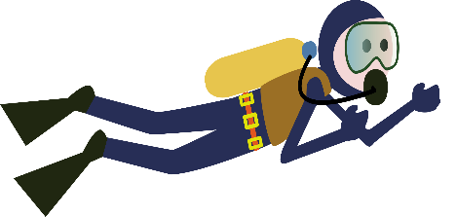

Consider the use of a gear bag such as the López which is sturdy
and large enough to accommodate all equipment, excluding the
cylinder and weight belt which would be managed separately.

